10
Fundamentals of AI and Machine Learning with Specific Examples of Application in Agriculture

Manoj Kumar Mahto, P. Laxmikanth, and V.S.S.P.L.N. Balaji Lanka
Vignan Institute of Technology and Science, Hyderabad, India

INTRODUCTION
The integration of artificial intelligence (AI) and machine learning (ML) techniques has ushered in a paradigm shift across diverse sectors, propel- ling innovative solutions that redefine conventional practices. Within this transformative landscape, the agricultural domain stands prominently, benefiting from the power of AI and ML to address complex challenges and elevate traditional farming practices. This chapter delves into the core fundamentals of AI and ML, contextualizing their principles within the realm of agriculture. By navigating the theoretical foundations and practi- cal applications of these technologies, readers will gain a comprehensive understanding of how AI and ML are reshaping the agricultural land- scape. AI and ML, once confined to the realm of science fiction, have now become pivotal tools in real-world applications. In agriculture, where the intricate interplay of weather patterns, soil conditions, and crop health shapes outcomes, AI and ML offer a powerful synergy. This chapter unravels the foundational concepts of AI and ML, providing insights into their inner workings. AI, often referred to as the simulation of human intelligence processes, empowers computers to execute tasks that would otherwise demand human intelligence. ML, a subset of AI, equips com- puters with the ability to learn from data and progressively improve their performance. Both technologies thrive on data, and in agriculture, where
178 DOI: 10.1201/9781003485179-10

Fundamentals of AI and Machine Learning with Speciflc Examples • 179

data-rich variables define outcomes, this symbiotic relationship takes center stage. A pivotal aspect of AI and ML in agriculture is their abil- ity to harness data’s potential to make informed decisions. Data collec- tion and preprocessing constitute the bedrock, ensuring that the data fed into AI and ML models is accurate, reliable, and relevant. This process involves gathering diverse datasets related to weather patterns, soil attri- butes, crop characteristics, and historical yields. Subsequently, feature extraction and engineering highlight the art of selecting the most relevant attributes from the data and refining it into a usable form that optimizes model performance. Model selection and evaluation further underscore the significance of informed choices. The process entails choosing suitable algorithms that align with the intricacies of the problem at hand. These algorithms undergo rigorous evaluation, ensuring that the model’s pre- dictions are dependable and actionable. The fusion of these stages results in AI and ML models that are primed to revolutionize agriculture.
The applications of AI and ML in agriculture span a wide range of chal- lenges and opportunities. Key areas include crop yield prediction, which empowers farmers to optimize resource allocation and productivity, and dis- ease detection, which facilitates rapid diagnosis and intervention. Precision farming, coupled with decision support systems, enhances efficiency through intelligent practices. Real-world examples highlight their impact, such as crop disease detection using convolutional neural networks (CNN), preci- sion agriculture with Decision Trees and Internet of Things (IoT) devices, and yield prediction via regression algorithms. These instances underscore AI and ML’s transformation from theory to practical change agents in agri- culture. However, ethical concerns related to data privacy and algorithmic transparency arise, necessitating thoughtful consideration. Additionally, ensuring equitable access and benefits across all agricultural stakeholders is crucial, given the technologies’ profound transformative potential.

FUNDAMENTALS OF AI AND ML
The fundamentals of AI and ML encompass key concepts that underpin their applications and advancements in various industries, including agriculture. AI refers to the creation of intelligent systems that can simulate human-like behaviors, while ML involves the development of algorithms that enable machines to learn from data and improve their performance over time.

AI
AI encompasses a range of techniques and approaches aimed at creating machines or systems that exhibit human-like intelligence. These systems can perform tasks such as problem-solving, decision-making, under- standing natural language, and recognizing patterns. AI techniques include rule-based systems, expert systems, neural networks, and natural language processing (NLP).

      - AI in Agriculture
AI in agriculture is spearheading a transformative shift in the way we cultivate crops. With the integration of cutting-edge technologies like agriculture robots and intelligent spraying systems, farmers can now pre- cisely manage their fields, optimizing crop yields while reducing resource consumption. These AI-driven solutions offer real-time crop and soil monitoring, enabling proactive responses to changing conditions and facilitating predictive insights into weather patterns and pest outbreaks. Additionally, AI plays a pivotal role in disease diagnosis, swiftly identify- ing and addressing potential threats to crop health. Moreover, AI-driven price forecasts provide farmers with valuable information for strategic decision-making. In essence, AI is not just revolutionizing agriculture; it’s paving the way for a more sustainable, efficient, and economically viable future for the industry. Figure 10.1 illustrates the comprehensive applica- tion of AI in the field of agriculture.

ML
ML is a subset of AI that focuses on developing algorithms that allow computers to learn from data and make predictions or decisions based on that learning. ML algorithms are categorized into supervised, unsu- pervised, and reinforcement learning, each catering to different types of tasks. Supervised learning involves training the model on labeled data, unsupervised learning involves finding patterns in unlabeled data, and reinforcement learning involves training agents to take actions to maxi- mize rewards.

      - ML in Agriculture
ML is revolutionizing agriculture by optimizing various facets of the indus- try, including crop management, water management, soil management,

Fundamentals of AI and Machine Learning with Speciflc Examples • 181

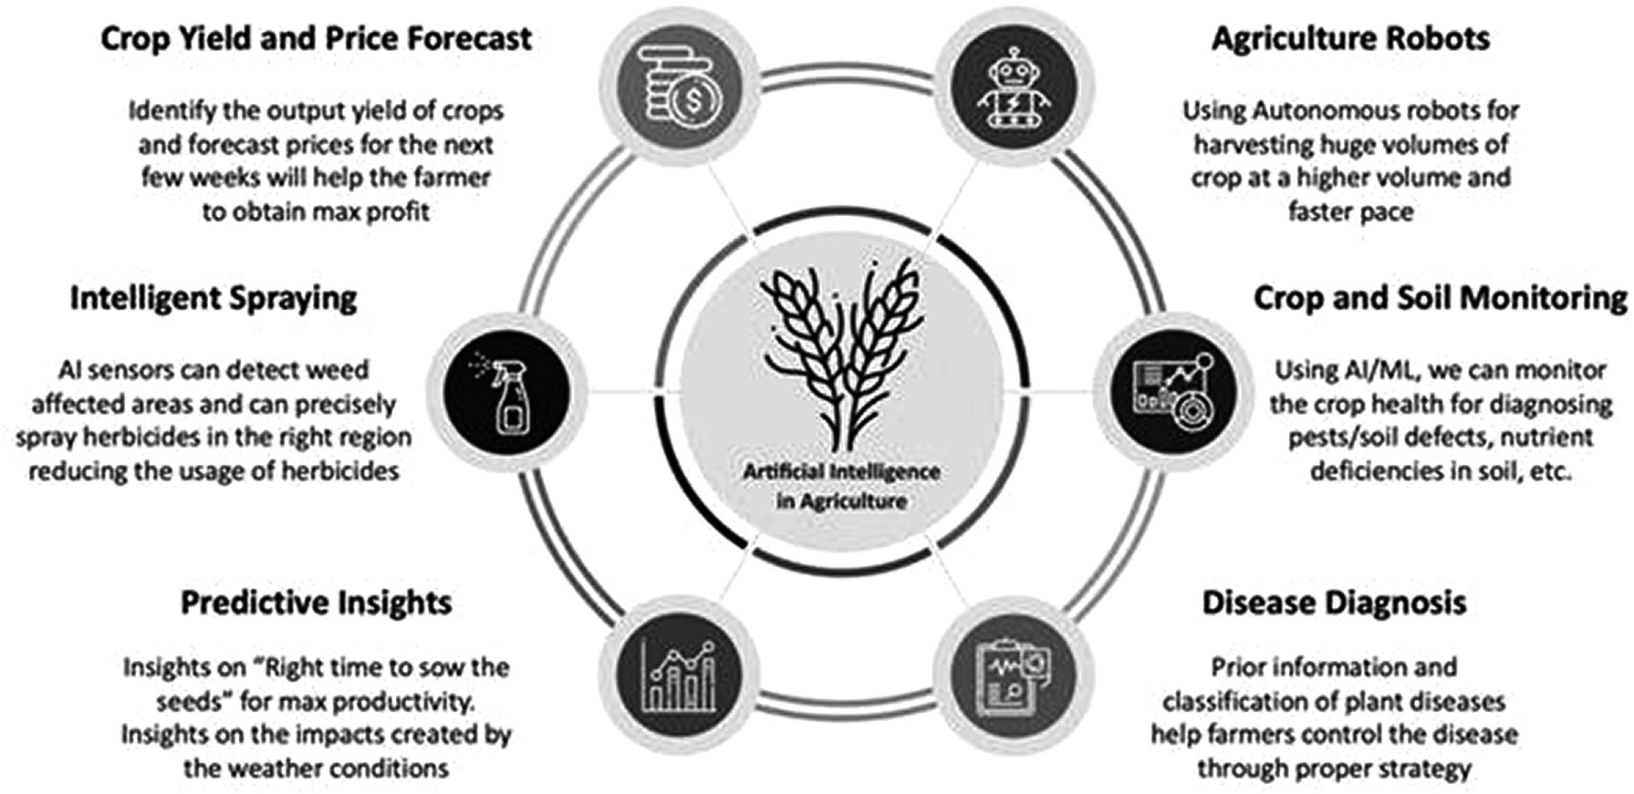

FIGURE 10.1
AI in agriculture.


Livestock Management
•This category includes the management pertaining to: Animal Welfare and Livestock Production
Soil Management
•This category is related to soil protection and soil management aspects
Water Management
•This category is associated with the optimal use of water resources
Crop Management
- This category involves studies concerning:
•Yields Prediction, Disease Detection, Weed Detection, Crop Recognition, and Crop Quality

FIGURE 10.2
ML in agriculture.
and livestock management. Through the analysis of vast datasets and real- time sensor data, ML algorithms empower farmers to make data-driven decisions. In crop management, ML predicts yields, disease outbreaks, and ideal planting times, ensuring maximum productivity and resource efficiency. Water management benefits from ML by determining precise irrigation schedules, conserving water resources, and mitigating drought risks. Soil management is enhanced, as ML evaluates soil health and nutri- ent levels, allowing for tailored fertilization plans. Livestock management utilizes ML to monitor animal health, optimize feed distribution, and enhance breeding programs, ultimately increasing the overall efficiency and sustainability of modern agriculture. Figure 10.2 visually represents the utilization of ML in the agricultural sector.

      - AI and ML Concepts in Agriculture
AI and ML concepts have ushered in a new era in agriculture, where the fusion of cutting-edge technology and traditional farming practices is optimizing efficiency and sustainability. Through crops and soil monitor- ing, these technologies offer real-time insights into soil health and crop conditions, helping farmers make informed decisions. By observing crop maturity and livestock health monitoring, AI and ML systems provide timely feedback on the development of crops and the well-being of live- stock, enabling precise interventions when needed. Intelligent spraying systems and automatic feeding mechanisms further enhance precision agriculture, reducing resource wastage and ensuring the judicious use of fertilizers and pesticides. In essence, these concepts are revolutionizing the industry by fostering a more informed, efficient, and eco-conscious


Intelligent Spraying
•UAVs with computer vision AI to automate spraying pesticides and fertilizers uniformly

Automatic Weeding
- Weeding robots to navigate and destroy existing weeds without applying herbicide
Livestock Health Monitoring
- Tracking and explaining cattle through Cattle Eye technology training data
Crops and Soil Monitoring
- Tracking crop health and predicting yields through visual sensing
Observing Crop Maturity
•Detecting maturity of vegetables using drones or unmanned aerials vehicles

FIGURE 10.3
AI and ML concepts in agriculture.
approach to farming. Figure 10.3 presents an overview of the concepts of AI and ML in the context of agriculture.

Data Collection and Preprocessing
Data collection and preprocessing constitute fundamental steps in the inte- gration of AI and ML techniques. The process involves gathering diverse datasets related to specific domains, ensuring their accuracy, completeness, and relevance for subsequent analysis. Data preprocessing, as a critical pre- cursor to analysis, encompasses activities like data cleaning, transforma- tion, and feature extraction to refine raw data into a usable form. These stages are pivotal for enhancing the quality of input data, which directly impacts the performance and reliability of AI and ML models [1]. By focusing on data quality and preparation, organizations can ensure that the subsequent AI and ML processes are based on accurate and meaning- ful information.

Feature Extraction and Engineering
Feature extraction and engineering play a central role in harnessing the power of AI and ML techniques. These processes involve identifying and selecting relevant attributes or features from the raw data that contrib- ute to the predictive capabilities of models. Feature extraction focuses on transforming the data into a format that is more suitable for analysis, often involving techniques like dimensionality reduction or transformation.

Feature engineering, on the other hand, involves creating new features or modifying existing ones to enhance the model’s performance. These processes are crucial for optimizing the input data that AI and ML algo- rithms rely on, leading to improved accuracy and efficiency in model pre- dictions [2]. Effective feature extraction and engineering enable models to capture the underlying patterns in the data, ultimately enhancing the overall performance and capabilities of AI and ML applications.

Model Selection and Evaluation
Model selection and evaluation constitute critical phases in the integration of AI and ML techniques. These stages are pivotal in determining the algo- rithms that best suit the problem at hand and assessing their performance. Model selection involves choosing from a range of algorithms based on their suitability for the specific task, data characteristics, and objectives. Subsequently, model evaluation involves testing the chosen algorithms using validation and testing datasets, measuring their accuracy, precision, recall, and other relevant metrics to assess their effectiveness [3]. Effective model selection and evaluation are imperative for ensuring that AI and ML models produce reliable predictions and insights, guiding decision- making processes in various domains.

APPLICATIONS OF AI AND ML IN AGRICULTURE
The applications of AI and ML in agriculture have revolutionized tra- ditional farming practices by leveraging data-driven insights to address complex challenges. These technologies have the potential to transform various aspects of agriculture, from improving crop yield predictions to enhancing disease detection and management. For instance, AI-powered models can analyze historical weather data, soil characteristics, and other variables to provide accurate predictions of crop yields, enabling farmers to make informed decisions about resource allocation and planning [4]. Additionally, AI and ML algorithms can detect and diagnose crop dis- eases by analyzing images of plants, leaves, or fruits, enabling timely inter- ventions to mitigate losses and optimize crop health [5]. The integration of AI and ML into precision agriculture has paved the way for optimized

resource utilization through targeted irrigation and fertilization, leading to increased efficiency and sustainability. These applications underscore the transformative potential of AI and ML in revolutionizing the agricul- tural sector. Figure 10.4 visually illustrates the various applications of AI and ML within the agricultural domain.

Crop Yield Prediction
Crop yield prediction, a cornerstone application within the realm of AI and ML in agriculture, has gained substantial attention due to its potential to optimize resource allocation and enhance food security. This predictive approach relies on the integration of historical and real-time data, encom- passing factors such as weather patterns, soil conditions, and agricultural practices. By employing advanced regression and ensemble techniques, AI and ML models can decipher intricate relationships between these vari- ables and predict future crop yields with remarkable accuracy [6]. Such predictions provide invaluable insights for farmers, allowing them to make informed decisions regarding planting strategies, irrigation sched- uling, and harvest planning. Ultimately, the integration of AI and ML into crop yield prediction not only improves agricultural efficiency but also contributes to sustainable practices by minimizing resource wastage and supporting global food supply chains. Figure 10.5 depicts the process of crop yield prediction.
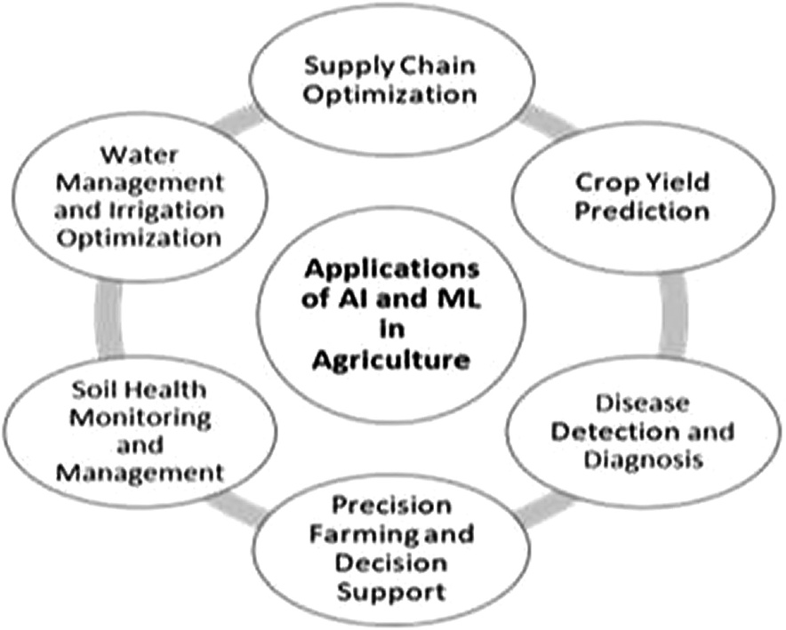
FIGURE 10.4
Application of AI and ML in agriculture.

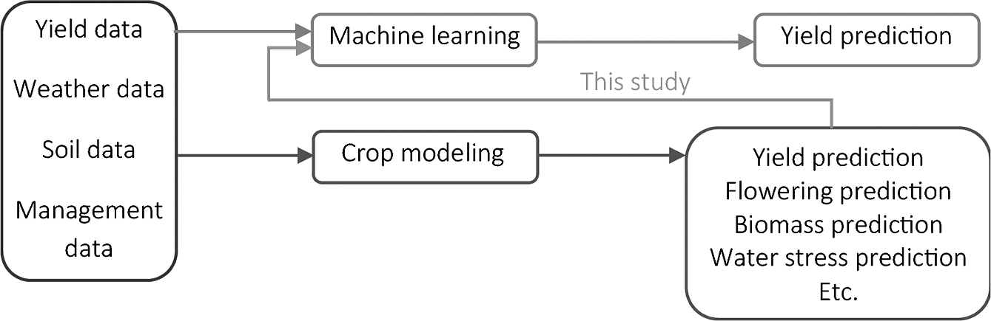

FIGURE 10.5
Crop yield prediction.

Disease Detection and Diagnosis
Disease detection and diagnosis in agriculture have been significantly transformed by the integration of AI and ML techniques. This applica- tion plays a pivotal role in the early identification and management of crop diseases, mitigating yield losses, and ensuring food security. By uti- lizing image recognition and classification algorithms, AI and ML mod- els can analyze images of plants, leaves, or fruits to accurately identify and diagnose various diseases [7]. These models learn from large datasets of images, allowing them to distinguish subtle visual cues that human eyes might miss. With timely and accurate disease detection, farmers can implement targeted interventions such as precise pesticide application or isolation of infected plants, minimizing the spread of diseases across crops [8]. This application showcases how AI and ML are driving innovation in agriculture by harnessing the power of data and automation to address critical challenges in disease management.

Precision Farming and Decision Support
Precision farming, coupled with decision support systems, represents a transformative application of AI and ML in modern agriculture. This approach leverages advanced technologies to optimize resource alloca- tion, enhance efficiency, and minimize environmental impacts. By inte- grating data from various sources such as satellites, sensors, and historical records, AI and ML models can provide real-time insights into soil condi- tions, weather patterns, and crop health [9]. These insights enable farmers to make informed decisions about when and where to apply irrigation, fertilizers, and pesticides, tailoring interventions to specific areas of need.

This not only increases yields but also reduces resource wastage and envi- ronmental pollution. Additionally, decision support systems equipped with AI algorithms can generate recommendations based on complex data analysis, aiding farmers in making timely and strategic choices for optimal crop management. The amalgamation of precision farming and decision support systems highlights how AI and ML are revolutionizing traditional agricultural practices by harnessing data-driven intelligence for sustainable and efficient outcomes.

Soil Health Monitoring and Management
Soil health monitoring and management have witnessed a paradigm shift with the integration of AI and ML techniques. This application offers a data-driven approach to assessing soil quality, nutrient content, and ero- sion risks, providing valuable insights for sustainable land management. By incorporating sensor data, historical records, and environmental vari- ables, AI and ML models can analyze complex relationships within the soil ecosystem [10]. These models can identify trends and patterns that enable farmers to make informed decisions about soil amendments, irri- gation schedules, and erosion control strategies. This not only enhances crop productivity but also contributes to long-term soil conservation and improved agricultural sustainability. The utilization of AI and ML in soil health monitoring exemplifies how technological innovation can empower farmers to make precision-driven decisions that optimize land use and resource utilization.

Water Management and Irrigation Optimization
Water management and irrigation optimization have been revolutionized by the integration of AI and ML techniques. This application addresses the critical need for efficient water usage in agriculture, especially in water- scarce regions. By leveraging data from sensors, weather forecasts, and soil moisture levels, AI and ML models can dynamically adjust irriga- tion schedules and volumes to match the specific water requirements of crops [11]. These models learn from historical and real-time data to make precise predictions, minimizing water wastage and enhancing crop yield. Moreover, AI-driven irrigation systems can respond to changing condi- tions, ensuring that crops receive the optimal amount of water without

overirrigation. This not only conserves water resources but also reduces energy consumption associated with pumping and distribution. The inte- gration of AI and ML in water management underscores their potential to address sustainability challenges in agriculture while ensuring productive and resilient farming systems.

CASE STUDIES
Case studies serve as compelling exemplars of the practical application and impact of AI and ML in diverse sectors, including agriculture. These real- world instances provide tangible evidence of how AI and ML technologies can drive transformative change. Case studies often feature innovative solutions that address specific challenges, such as crop disease detection, yield prediction, and precision farming. Through the integration of AI and ML algorithms, these studies showcase enhanced accuracy, efficiency, and sustainability in agricultural practices [12]. By analyzing these cases, stakeholders can glean insights into the potential benefits, challenges, and strategies for the successful implementation of AI and ML technologies in the agricultural domain, thereby fostering informed decision-making and fostering a resilient food system.

Crop Disease Detection Using CNN
Crop disease detection using CNNs has emerged as a prominent applica- tion of AI and ML in agriculture. CNNs are specialized deep-learning models designed to process visual data, making them well-suited for analyzing images of crops and detecting diseases. By learning from large datasets of annotated images, CNNs can identify subtle visual patterns associated with various diseases, enabling accurate and early detection [13]. These models have showcased impressive performance in classify- ing diseases across different crops, offering potential solutions for timely interventions and targeted management. The utilization of CNNs in crop disease detection showcases the capability of AI and ML to contribute to sustainable agriculture by enhancing disease management practices. Figure 10.6 showcases the implementation of crop disease detection through the utilization of CNNs.

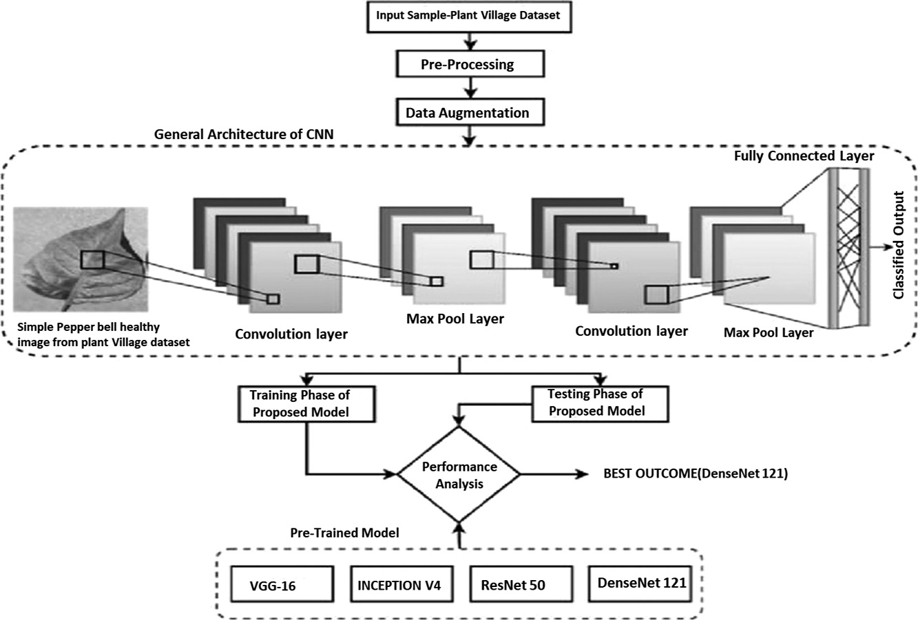

FIGURE 10.6
Crop disease detection using CNNs.

Precision Agriculture with Decision Trees and IoT
Precision agriculture, facilitated by Decision Trees and the IoT, stands as a prime illustration of the transformative impact of AI and ML in the agricultural landscape. Decision Trees are ML algorithms that excel in classification and regression tasks, making them valuable tools for guid- ing agricultural decisions. When integrated with IoT devices that collect real-time data from fields, Decision Trees can provide actionable insights into crop health, soil moisture, and environmental conditions [14]. This synergy allows farmers to implement precise interventions, such as tar- geted irrigation and nutrient application, optimizing resource utilization and enhancing yield. The fusion of Decision Trees and IoT underscores the potential of AI and ML to revolutionize traditional farming practices by enabling data-driven precision in agricultural management. Figure
10.7 illustrates the implementation of precision agriculture, integrating Decision Trees and the IoT for improved farming practices.

Yield Prediction Using Regression Algorithms
Yield prediction using regression algorithms exemplifies the application of AI and ML in agriculture, offering valuable insights into future crop

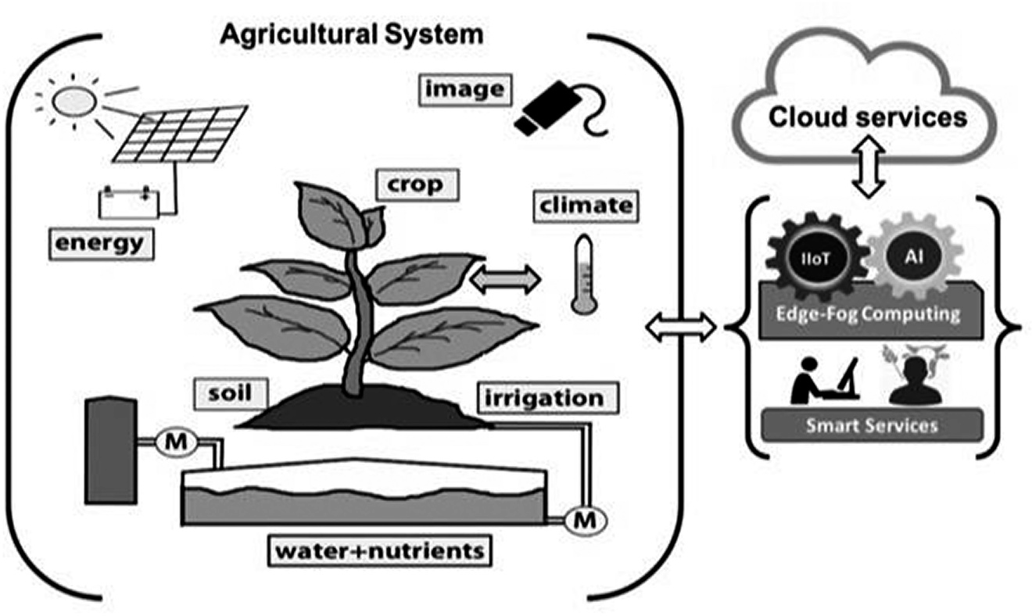

FIGURE 10.7
Precision agriculture with decision trees and IoT.

production. Regression algorithms, a subset of ML techniques, enable the modeling of relationships between input variables and target outcomes. By analyzing historical data encompassing factors such as weather con- ditions, soil properties, and agricultural practices, these algorithms can generate predictive models that estimate crop yields with accuracy [15]. Such predictions empower farmers with data-driven insights for informed decision-making, including resource allocation and market planning. The successful application of regression algorithms in yield prediction show- cases the potential of AI and ML to enhance agricultural productivity and resilience. Figure 10.8 visualizes the process of yield prediction utilizing regression algorithms.

CHALLENGES AND FUTURE DIRECTIONS
The integration of AI and ML concepts in agriculture presents both oppor- tunities and challenges that warrant consideration. While AI and ML offer transformative potential, several challenges must be addressed to ensure their effective implementation and sustainable impact in agriculture. Data quality and availability remain a significant concern, as reliable and comprehensive datasets are essential for training accurate models [16].

Start

Fetch the rainfall, temperature data for current year

Treat the whole data as training set
Predict the current year Yield using the best model and best parameter set

Stop

FIGURE 10.8
Yield prediction using regression algorithms.

Privacy and security issues also come into play, particularly as agricul- tural data often involves sensitive information about farming practices and land management. Ensuring the ethical and responsible use of AI and ML technologies is paramount to building trust among stakeholders [4].

Challenges
Furthermore, the interpretability and explain ability of AI and ML models pose challenges in gaining insights into how decisions are made. Black-box models may hinder the adoption of these technologies, especially in sec- tors like agriculture, where transparency is crucial [17]. Bridging the gap between technical experts and domain-specific farmers is another chal- lenge. Effective communication and education are necessary to empower farmers to understand, trust, and utilize AI-powered solutions [7].

      - Data Quality and Availability
The necessity of reliable and comprehensive datasets for training accu- rate AI and ML models in the field of agriculture cannot be overstated. In this context, the quality and composition of the data have a direct impact on the performance and robustness of the models. Inconsistent, incom- plete, or biased data can significantly hinder the effectiveness of predictive models and decision-making processes [18]. The accuracy of predictions and the reliability of insights depend on the integrity of the input data, making data quality assurance a critical concern. Ensuring that datasets encompass a diverse range of conditions, scenarios, and variables is essen- tial to avoid biased or skewed model outcomes. Addressing these data- related challenges is pivotal to unlocking the full potential of AI and ML in improving agricultural practices and outcomes.

      - Privacy and Security
Agricultural data frequently encompasses a wealth of sensitive informa- tion related to farming practices, land management strategies, and even

personal details of farmers. This wealth of personal and proprietary data underscores the critical importance of ensuring robust data privacy and security mechanisms within the context of AI and ML applications in agriculture. As such, safeguarding this data becomes paramount not only to comply with regulatory requirements but also to foster trust and cooperation among farmers, stakeholders, and technology developers [19]. Effective data encryption, access controls, and anonymization techniques are essential to protect confidential information from unauthorized access or breaches. By prioritizing data privacy and security, the agricultural industry can create an environment where stakeholders are confident in the responsible use of AI and ML technologies for enhancing productivity and sustainability.

      - Interpretability and Explainability
The opaqueness inherent in black-box AI and ML models can significantly impede the comprehension of decision-making mechanisms, a concern that holds even more significance within the agricultural domain where transparency is of paramount importance [17]. The inability to discern the rationale behind predictions and recommendations hinders the adop- tion of these technologies among stakeholders. Given the complex and high-stakes nature of agricultural practices, the need for interpretable models becomes increasingly evident. To establish trust and foster wider acceptance, efforts are directed toward developing AI and ML models with enhanced interpretability. By employing techniques that allow mod- els to provide explanations for their decisions, stakeholders gain insights into the factors influencing outcomes. Such transparent models not only facilitate informed decision-making but also aid in identifying potential biases, errors, or shortcomings, contributing to responsible AI deploy- ment in agriculture.

      - Communication and Education
Narrowing the divide between technical experts engaged in AI solution development and the end-users, who are often farmers, presents a for- midable challenge. This challenge is rooted in the distinct backgrounds, terminologies, and perspectives of these two groups. Effective communica- tion and education emerge as pivotal components to bridge this gap and facilitate the successful adoption of AI-powered solutions in agriculture [7]. By translating complex technical concepts into accessible language and

relatable scenarios, experts can convey the value and benefits of AI to farmers. Additionally, educational initiatives can empower farmers with the knowledge required to comprehend the potential applications, limi- tations, and implications of AI in their practices. Such initiatives foster an environment where farmers can make informed decisions, trust the technology, and seamlessly integrate AI-powered solutions into their agri- cultural processes.

Future Directions
As for future directions, the refinement of AI and ML algorithms tailored specifically for agricultural challenges holds promise. Developments in Explainable AI (XAI) could address the transparency concern, provid- ing more interpretable models that enable stakeholders to comprehend decision-making processes. Integrating AI with other technologies, such as IoT devices, remote sensing, and robotics, can further enhance data collection and decision support systems. Collaborative efforts involving researchers, agricultural experts, and policymakers are essential to cre- ate frameworks that encourage responsible AI deployment, address chal- lenges, and promote equitable access to AI benefits. Figure 10.9 outlines the potential future directions in the field of agriculture.
Customization for
Local
Scaling and Contexts Accessibility
Tailored Algorithms
Regulatory Frameworks
Future Directions in Agriculture
Explainable AI
Ethical Considera tions
Collaborative Efforts
Integration with IoT and Remote Sensing
FIGURE 10.9
Future directions in agriculture.

      - Tailored Algorithms
Tailoring AI and ML algorithms to effectively address the unique chal- lenges encountered in agriculture has the potential to significantly amplify the accuracy and applicability of these technologies in farming contexts. This approach involves understanding the intricacies of agricul- tural systems, such as crop growth patterns, soil characteristics, weather dynamics, and pest behavior, and designing algorithms that leverage this domain-specific knowledge [20]. By customizing algorithms to align with the nuances of agriculture, the resulting models can provide more relevant and actionable insights to farmers. This adaptability not only enhances the predictive power of AI but also increases its practical utility in real-world agricultural scenarios.

      - Explainable AI
Progress in XAI has the potential to drive the development of models that are inherently more interpretable, offering a solution to the challenge of understanding the reasoning behind AI-based decisions. This progress becomes particularly valuable in agriculture, where transparent decision- making processes are crucial for building trust among farmers, stake- holders, and end-users [17]. By employing techniques that provide clear explanations for the outputs generated by AI models, stakeholders can gain insights into the factors and features influencing the outcomes. This enhanced interpretability empowers farmers to comprehend the ratio- nale behind AI-driven recommendations and predictions, contributing to their acceptance and informed decision-making. The advancements in XAI represent a significant step toward creating more transparent and trustworthy AI models that align with the needs and expectations of the agricultural community.

      - Integration with IoT and Remote Sensing
The convergence of AI with IoT devices, remote sensing technologies, and robotics has the potential to yield powerful synergistic solutions that revolutionize data collection, monitoring, and decision support in the agricultural sector [21]. By amalgamating AI’s analytical prowess with the data streams generated by IoT devices and remote sensors, farmers can access real-time information about soil conditions, weather patterns, crop health, and machinery operations [22]. This dynamic data ecosystem

empowers farmers to make timely and informed decisions, enabling pro- active interventions to address challenges like irrigation management, pest outbreaks, and yield optimization. Moreover, the integration of robotics further amplifies these capabilities, facilitating precise and auto- mated actions such as targeted pesticide application or crop harvesting [23]. This holistic approach capitalizes on AI’s ability to process complex data, creating a seamless fusion of technologies that augment agricultural productivity, sustainability, and resilience.

      - Collaborative Efforts
Effective collaboration among researchers, agricultural experts, policy- makers, and technology developers emerges as a fundamental prerequi- site for the successful integration of AI in agriculture. This collaborative approach is imperative due to the multidimensional nature of challenges and opportunities presented by AI deployment [24]. By fostering a cross- disciplinary dialogue, stakeholders can collectively formulate frameworks that not only facilitate the responsible and ethical deployment of AI but also address the intricacies associated with data privacy, bias mitigation, and equitable access to technological benefits. These collaborative efforts culminate in the development of guidelines and regulations that promote transparent and fair AI adoption, ultimately contributing to the creation of an inclusive and sustainable agricultural ecosystem.

      - Customization for Local Contexts
Tailoring AI solutions to align with specific local agricultural practices, diverse climate conditions, and intricate socio-economic factors is impera- tive for harnessing the full potential of these technologies and ensuring their efficacy. Agricultural systems vary widely across regions, and a one- size-fits-all approach may not yield optimal outcomes [25]. By customizing AI solutions to accommodate local nuances, such as crop cycles, soil types, and resource availability, the technology can be optimized to yield action- able insights that resonate with the unique needs of farmers. Moreover, accounting for socio-economic factors ensures that the adoption of AI solutions is both relevant and beneficial to local communities, fostering sustained engagement and participation. This adaptability enhances the overall effectiveness of AI applications in agriculture, driving positive out- comes that extend beyond productivity gains.

      - Ethical Considerations
Dealing with ethical considerations related to the implementation of AI in agriculture assumes critical significance, encompassing imperatives such as equitable technology access, bias mitigation, and safeguarding the wel- fare of farm workers. These concerns underscore the need for a compre- hensive and responsible approach to AI deployment in the agricultural sector. Ensuring equitable access to AI technology becomes pivotal to preventing the digital divide and enabling all farmers, irrespective of their resources or location, to benefit from technological advancements [26]. The crucial aspect of minimizing biases in AI systems is vital to prevent discriminatory outcomes and ensure fair decision-making, particularly in processes like crop yield prediction or disease diagnosis. Lastly, preserv- ing the well-being of farm workers is paramount, as automation and AI integration can reshape labor dynamics, necessitating thoughtful plan- ning and measures to prevent any adverse impacts on livelihoods [27]. Adhering to these ethical considerations is indispensable for fostering a sustainable and equitable AI transformation in agriculture.

      - Regulatory Frameworks
Formulating suitable regulations and policies for the utilization of AI applications in the agricultural sector holds significant potential to estab- lish a framework that guides the safe and responsible integration of these technologies. The multifaceted nature of AI’s impact necessitates gov- ernance that encompasses aspects such as data privacy, security, ethical considerations, and compliance with industry standards [28]. By devis- ing regulations that address these concerns, policymakers can facilitate the ethical deployment of AI while maintaining a fair and level playing field for all stakeholders involved. These regulations serve as a safeguard against potential risks and help build a conducive environment where AI adoption is characterized by transparency, accountability, and adherence to best practices.

      - Scaling and Accessibility
Ensuring the accessibility of AI and ML solutions to small-scale farm- ers and remote regions stands as a pivotal imperative in achieving broad-spectrum impact and diminishing disparities in the adoption of agricultural technology. In many regions, small-scale farmers form the backbone of the agricultural sector, and extending the benefits of AI and

ML to them is crucial for inclusive growth [29]. Additionally, reaching remote areas with limited connectivity and resources requires innovative solutions to bridge the digital divide and bring the advantages of AI to those who need them most. By prioritizing accessibility, policymakers, technology developers, and stakeholders contribute to the democratiza- tion of agricultural advancements, empowering farmers across different scales and geographical contexts.
While AI and ML have shown great potential in transforming agricul- ture, several challenges need to be navigated to ensure their successful integration. Addressing data quality, privacy, ethical considerations, and interpretability are crucial steps. Looking ahead, refining algorithms, embracing XAI, and fostering collaborative ecosystems can drive AI’s role in reshaping agriculture for a more sustainable and resilient future.

CONCLUSION
The fusion of AI and ML with agriculture holds immense promise, offer- ing transformative potential across various aspects of the sector. This comprehensive exploration has shed light on the fundamental concepts of AI and ML, their data-driven nature, feature extraction, model selec- tion, and evaluation. The applications discussed, ranging from crop yield prediction to disease detection and precision farming, underscore how these technologies are reshaping traditional practices to enhance produc- tivity, sustainability, and resource optimization. Moreover, the challenges and considerations surrounding data quality, privacy, transparency, and stakeholder collaboration emphasize the need for responsible and ethical deployment.
As AI-driven solutions continue to advance, the integration of XAI and collaboration between experts and farmers are expected to enhance transparency and adoption. The evolving landscape of AI in agriculture necessitates the development of frameworks that address ethical, regula- tory, and accessibility concerns. These efforts are vital to ensure that AI and ML technologies are not only accessible but also contribute to bridg- ing disparities in technology adoption among different agricultural stakeholders. Ultimately, this integration presents an exciting trajectory toward a more resilient, productive, and sustainable agricultural future, where technology augments human expertise for the collective benefit of farmers, communities, and the global food supply.

REFERENCES
- H. Witten, E. Frank, and M. A. Hall, Data Mining: Practical Machine Learning Tools and Techniques (4th ed.), Morgan Kaufmann, 2016.
- I. Guyon and A. Elisseeff, “An Introduction to Variable and Feature Selection,” Journal of Machine Learning Research, vol. 3, pp. 1157–1182, 2003.
- T. Hastie, R. Tibshirani, and J. Friedman, The Elements of Statistical Learning: Data Mining, Inference, and Prediction (2nd ed.), Springer, 2009.
- A. Kamilaris, F. X. Prenafeta-Boldú, and A. Likas, “A Review on the Practice of Big Data Analysis in Agriculture,” Computers and Electronics in Agriculture, vol. 143, pp. 23–37, 2017.
- S. P. Mohanty, D. P. Hughes, and M. Salathé, “Using Deep Learning for Image-Based Plant Disease Detection,” Frontiers in Plant Science, vol. 7, pp. 1–10, 2016.
- Y. Ruiz-García and E. Gómez-Plaza, “Elicitors: A Tool for Improving Fruit Phenolic Content,” Agriculture, vol. 3, no. 1, pp. 33–52, 2013.
- A. Kamilaris, A. Kartakoullis, and F. X. Prenafeta-Boldú, “A Review on the Use of Artificial Intelligence in Crop Disease Detection,” Precision Agriculture, vol. 19, no. 5,
pp. 881–905, 2018.
- D. Mitra, S. Gupta, D. Srivastava, and S. Sani, “Plant Disease Identification Using Convolution Neural Networks,” in D. Srivastava, N. Sharma, D. Sinwar, J. H. Yousif,
H. P. Gupta (eds) Intelligent Internet of Things for Smart Healthcare Systems, CRC Press, 2023, pp. 203–215.
- A. Srinivasan, K. Seetharam, and S. Singh, “Precision Agriculture: An Overview and Advances in Data Analytics for Site-Specific Crop Management,” Computers and Electronics in Agriculture, vol. 172, 2020.
- Y. Zheng, X. Zhang, Q. Cheng, and X. Xu, “A Review on the Applications of Artificial Intelligence in Soil Monitoring and Management,” Journal of Integrative Agriculture, vol. 20, no. 4, pp. 865–875, 2021.
- E. Hassanpour Adeh, F. Abbasi, and H. R. Maier, “A Review of Data-Driven Approaches for Enhancing Water Management and Crop Yield for Irrigation Systems,” Journal of Hydrology, vol. 568, pp. 285–310, 2019.
- A. Mousavi, M. Gharakhani, and A. Mosavi, “Machine Learning in Agriculture: A Review,” Computers and Electronics in Agriculture, vol. 170, 2020.
- A. Fuentes, S. Yoon, and D. S. Park, “A Deep Learning Framework for Groundnut Leaf Disease Identification and Severity Estimation,” Computers and Electronics in Agriculture, vol. 161, pp. 272–282, 2018.
- S. K. Pathan, M. A. Mohammed, and M. H. Anisi, “Internet of Things (IoT) Applications in Precision Agriculture,” Computers and Electronics in Agriculture, vol. 173, 2020.
- S. Shakya, D. Murthy, and M. Kumar, “Crop Yield Prediction Using Machine Learning: A Review,” Computers and Electronics in Agriculture, vol. 184, 2021.
- T. N. N. Lam, V. T. Truong, D. C. Nguyen, D. Q. Le, and T. D. Nguyen, “Applications of Machine Learning in Agriculture: A Survey,” Computers and Electronics in Agriculture, vol. 175, 2020.
- R. Guidotti et al., “A Survey of Methods for Explaining Black Box Models,” ACM Computing Surveys, vol. 51, no. 5, pp. 1–42, 2018.

- I. Lopes and F. Bacao, “A Review on Data Quality Assessment Methods for Machine Learning,” Data & Knowledge Engineering, vol. 134, 2021.
- M. Rabbi, M. A. Rahman, D. R. Kowalski, E. M. Berke, D. B. Flora, and L. C. Brewer, “Protecting Confidentiality of Personal Health Information in Small Health Data Sets,” Journal of Medical Internet Research, vol. 21, no. 7, 2019.
- A. M. Rady and Y. M. Neinaa, “Predicting Yield of Summer Maize Crop using Artificial Neural Networks (ANNs) and Multiple Linear Regression (MLR) Models,” Computers and Electronics in Agriculture, vol. 186, 2021.
- M. Goyal and D. Srivastava, “A Behaviour-Based Authentication to Internet of Things Using Machine Learning,” in S. L. Tripathi, D. K. Singh, S. Padmanaban, and P. Raja (eds) Design and Development of Efficient Energy Systems, 2022, pp. 245–263.
- N. Zhang, R. Wang, and Y. Huang, “Smart Agriculture: An Integrated IoT Framework for Agricultural Decision Making,” IEEE Internet of Things Journal, vol. 8, no. 3, pp. 1705–1715, 2021.
- E. Guzmán, D. Megías, and M. Torres-Torriti, “A Review on Robotics in Agriculture,”
Precision Agriculture, vol. 20, no. 4, pp. 693–719, 2019.
- P. Capper, T. Beck, G. Robinson, and J. Arthur, “Agricultural Development and Environmental Policy: A Case for Collaboration in Meeting 21st Century Challenges,” Journal of Environmental Quality, vol. 47, no. 4, pp. 644–653, 2018.
- A. Kamilaris, A. Kartakoullis, and F. X. Prenafeta-Boldú, “A Review on the Use of AI in Agriculture,” Information Processing in Agriculture, vol. 7, no. 4, pp. 528–550, 2020.
- D. G. Tadesse, G. Caramanna, A. Ploeger, A. Kessler, R. Strahan, and K. Naveed, “Artificial Intelligence in Agriculture: A Brief Introduction and Review,” IEEE Access, vol. 9, pp. 18669–18684, 2021.
- S. Fountas et al., “Agricultural Robotics in Support of a Sustainable Rural Development,” Sustainability, vol. 11, no. 5, 2019.
- H. Lütkepohl and M. Schomaker, “Responsible AI for the Food and Agriculture Sector: Overview, Challenges, and Perspectives,” European Journal of Operational Research, vol. 295, no. 2, pp. 465–475, 2021.
- A. Buckwell, J. Mills, J. Ingram, J. Dwyer, and N. Powell, “A Review of Evidence for the Relationship between Farm Business Management Practices and Farm Performance,” Land Use Policy, vol. 97, 2020.

